Graphics Report

Contents

Sound 3

Ambient water sounds 3

Animations 3

Explosion Animation 3

Shot 3

Enemy Death 3

Explosion Pseudo Code 3

Player Movement animations 3

Forward & Backwards 3

Player Animation Code 3

Enemy movement, damaged texture & Health Bars 4

Enemy Damage and movement animations Code 4

Enemy health Bar Code 4

Player Health And Ultimate Weapon cooldown Bars 4

Player Health and Cooldown bar Code 5

Upgrades 5

Heal 5

Number of shots 5

Min Upgrade & Max Upgrade 5

Code 5

Fire rate 5

Min Upgrade & Max Upgrade 5

Code 6

Range 6

Min Upgrade 6

Max Upgrade 6

Code 6

Speed 6

Ultimate Weapon 7

Code Snippets 7

Homogenous Terrain 8

Shallow Water 8

Beach 8

Enemy collide 8

Enemy AI 9

Movement 9

Shooting 9

Collision 9

Difficulty progression 10

Standard enemies & Fully upgraded enemies 10

Pseudo Code 10

OBB Collisions 11

Collision Boxes Drawn 11

UI Text 11

Kills & Scrap Level 11

Upgrade information 11

Boss Spawned 11

Low Health 12

Boss AI 12

Movement 12

Shooting 12

Difficulty Progression 13

Standard shooting & Maximum Shooting 13

Scrap 13

Pause Game 14

User Guide 15

# Sound

## Ambient water sounds



# Animations

## Explosion Animation

### Shot

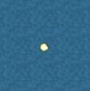

### Enemy Death

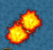

### Explosion Pseudo Code

In Explosion object render function:

(hp starts at 18(*number of frames in animation*))

glBindTexture(GL_TEXTURE_2D, explosion[i]);

i++;

hp--;

if(hp <= 0){

Delete This object;

}

## Player Movement animations

### Forward & Backwards

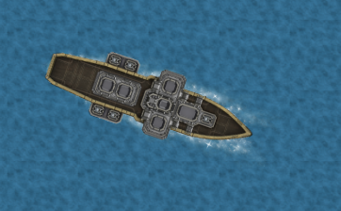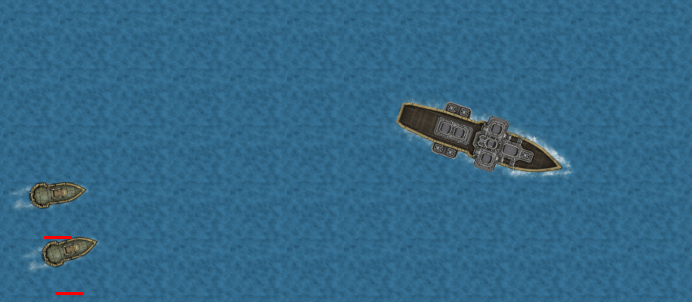

### Player Animation Code

texture = no wake.

animation[0-4] = moving forward.

animaton[5-9] = moving backwards.

if (Vtri < -0.01){

glBindTexture(GL_TEXTURE_2D, animation[i + 5]);

}

else if (Vtri > 0.01){

glBindTexture(GL_TEXTURE_2D, animation[i]);

}

else{

glBindTexture(GL_TEXTURE_2D, texture);

}

i++;

## Enemy movement, damaged texture & Health Bars

 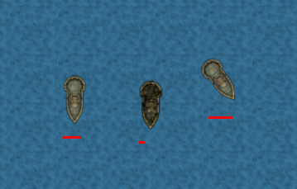

### Enemy Damage and movement animations Code

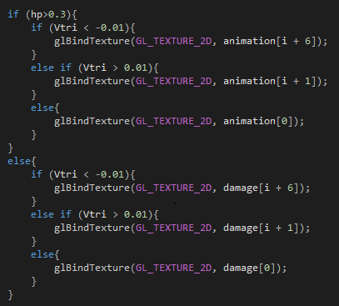

### Enemy health Bar Code

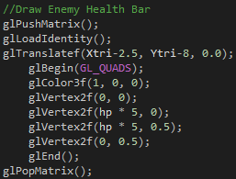

## Player Health And Ultimate Weapon cooldown Bars

drawHealth() & drawCooldown() functions used to draw both bars.

 

### Player Health and Cooldown bar Code

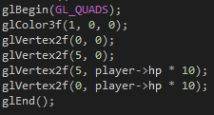 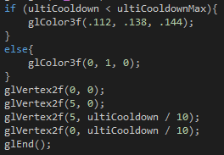

# Upgrades

## Heal

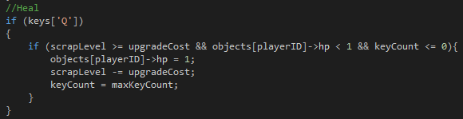

## Number of shots

### Min Upgrade Max Upgrade

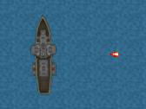

### Code

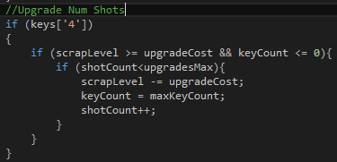

## Fire rate

### Min Upgrade Max Upgrade

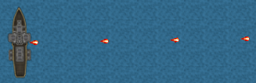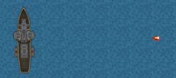

### Code

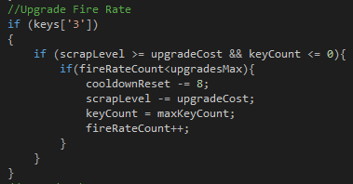

## Range

### Min Upgrade

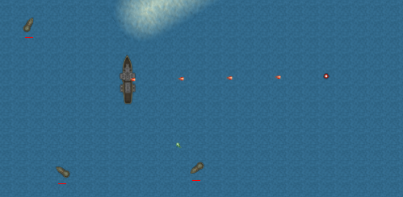

### Max Upgrade

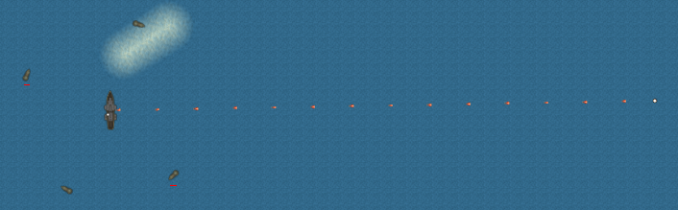

### Code

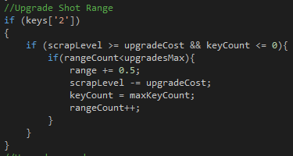

## Speed

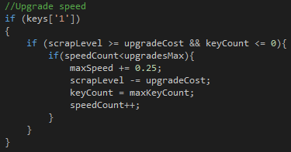

## Ultimate Weapon

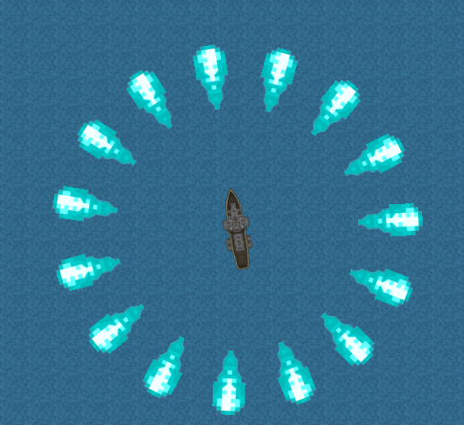

### Code Snippets

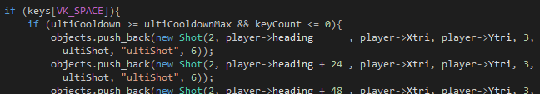

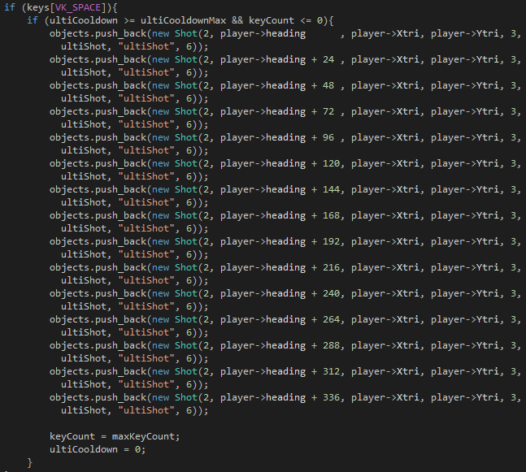

# Homogenous Terrain

## Shallow Water

Slows the player when sailing over it.

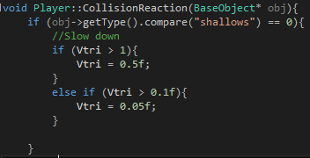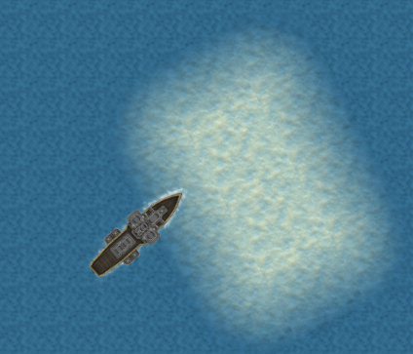

## Beach

Damages the player on collision and reverses movement so is impassable.

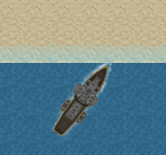

## Enemy collide

When the player collides with an enemy it damages both the player and the enemy and the player will bounce off.

In players collisionReaction():

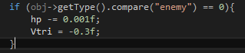

In enemies collisionReaction():

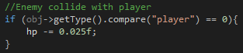

# Enemy AI

## Movement

When you get within a certain range of an enemy they will begin to move towards you. This is done by drawing a line between the enemy and the player then performing actions based on its length.

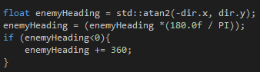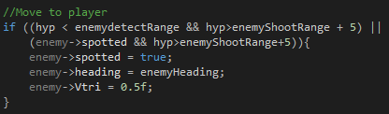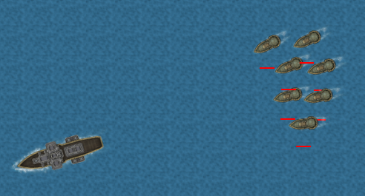

## Shooting

When they get close enough they will turn broadside and begin to fire at you.

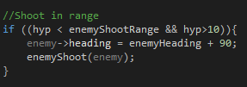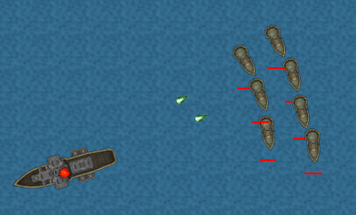

## Collision

Enemies correctly collide with each other so they do not overlap as seen in the image above.

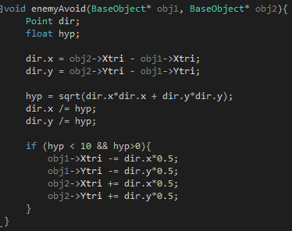

When an enemy collides with the edge of the map or the boss they will change their heading based on the angle they collided at.

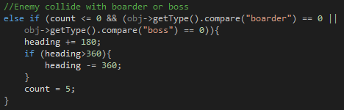

## Difficulty progression

As you kill more enemies they will become harder, detecting you from further away, firing more shots and faster and shooting from further away.

### Standard enemies Fully upgraded enemies

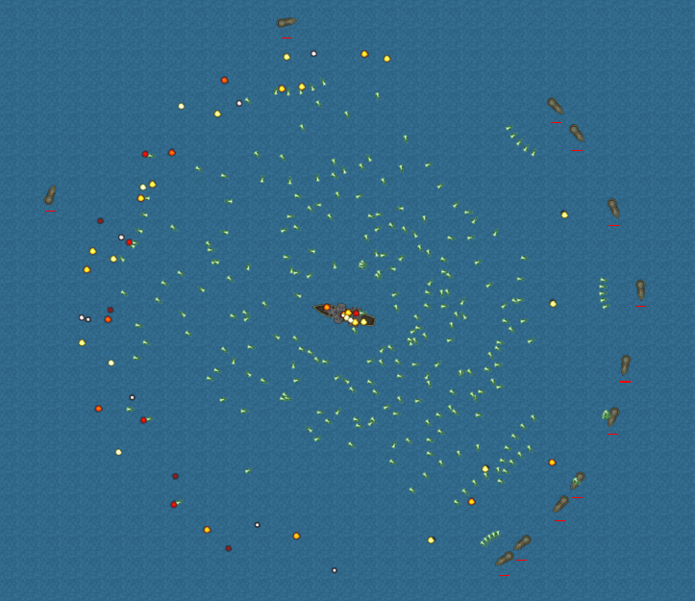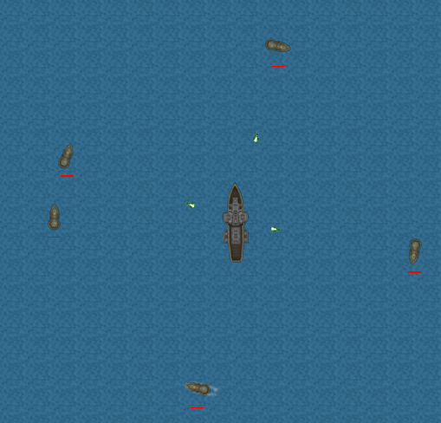

### Pseudo Code

Shot creation code:

new Shot(enemyRange, enemy->heading - 70, enemy->Xtri, enemy->Ytri, 3, enemyShotTexture, "enemyShot")

in enemyShoot Function:

If(Number of kills > 40){

Create 5 shot objects;

}

else If(Number of kills > 30){

Create 4 shot objects;

}

else If(Number of kills > 20){

Create 3 shot objects;

}

else If(Number of kills > 10){

Create 2 shot objects;

}

else If(Number of kills > 0){

Create 1 shot object;

}

# OBB Collisions

All collision are done using Oriented bounding boxes. Only certain objects need to collision check with each other so the shouldCollide() function in main.cpp is used to determine what should collide with what. E.g. –

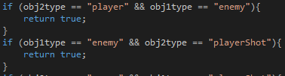

## Collision Boxes Drawn

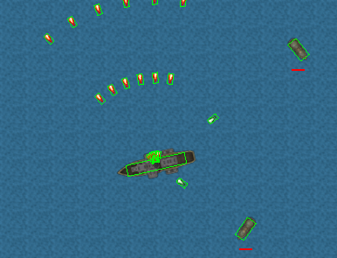

# UI Text

All text is drawn using the freeType library and its print method. E.g.



## Kills & Scrap Level

drawKills() & drawScrap() functions



## Upgrade information

drawUpgrades() function

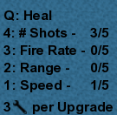

## Boss Spawned

When the player has reached the required amount off kills the boss will spawn and this message will display -



## Low Health

When the players health is low a warning appears -

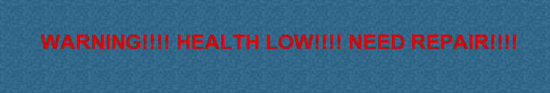

# Boss AI

## Movement

When the boss has spawned it will move towards the player from any distance. Similar to the standard enemies the movement is done by drawing a line between the player and the boss and the boss will change its heading to follow the line and move along it.

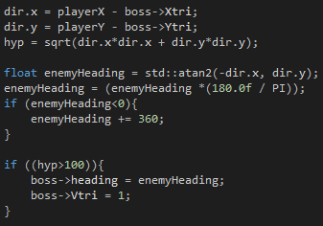

## Shooting

Unlike the normal enemies, the boss will shoot in a spiral around itself, rather than just shooting directly at the player.

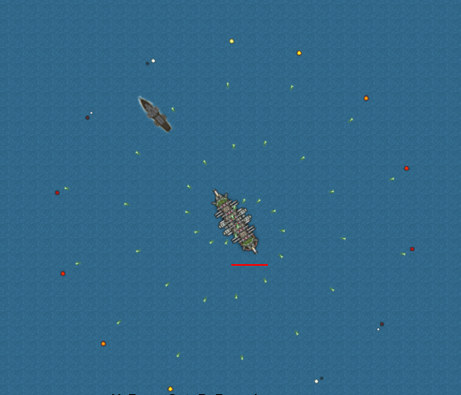

## Difficulty Progression

As the bosses health lowers, the amount of shots that it fires will increase. This is performed in the moveBoss() & bossShootCircle() functions in main.cpp.

### Standard shooting Maximum Shooting

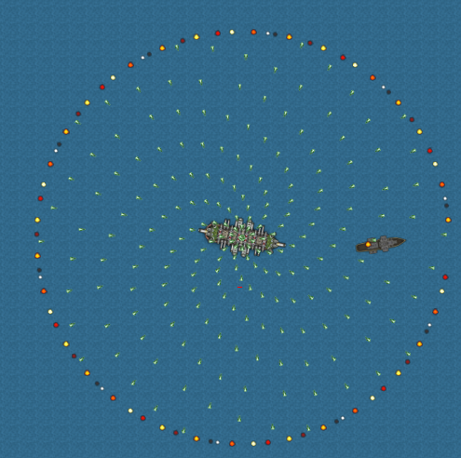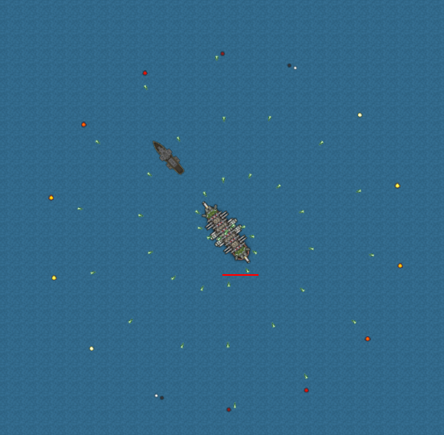

# Scrap

When the player kills an enemy a scrap object will drop, and if it within a certain range of the player it will move towards them.

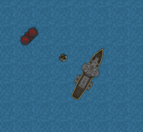 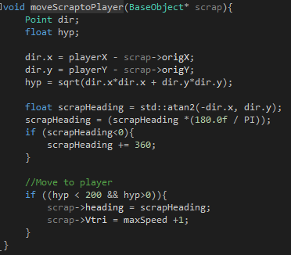

# Pause Game

Pressing the ‘P’ key will pause the game and show a message prompt.

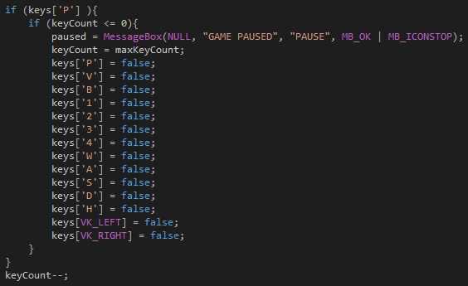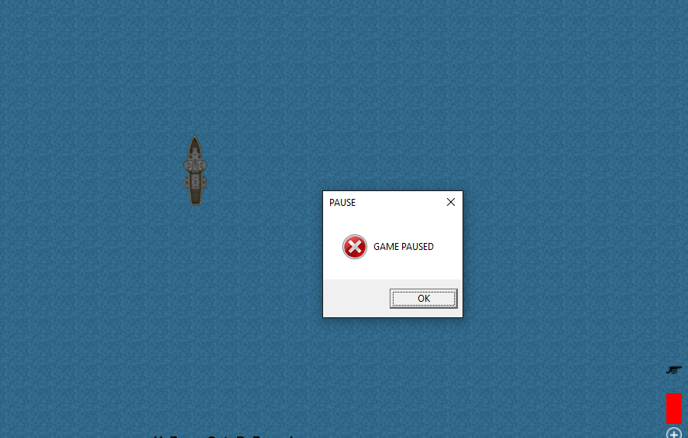

# F:\UEA CMP Year 2\Graphics 1\Assignment\Assignment\User Guide.pngUser Guide